Frog Lead-Zinc Project Northern BC

Short Note: Geophysics Data Review, June 22, 2015
By Jules J. Lajoie, PhD, PEng.

Introduction

This short note reports on observations made upon reviewing the geophysical data on the Frog Pb-Zn project in northern BC. It is assumed that the reader is well familiar with the property history which is not repeated herein. A number of assessment reports were reviewed, along with a mid nineties government aeromag survey. Important information was registered into NAD83 map layers in a Geosoft Base map, all now available for export, and from which screen snags are included herein. As the assessment reports are pre 1990, their maps are not georeferenced in UTM. Thus it was necessary to identify distinctive creeks for georeferencing purposes.

The digital aeromag line data were located on a government server, downloaded, gridded, and plotted. The published government aeromag map showing creeks was then imported and georeferenced onto this data, and from this, traces of the creeks were extracted for georeferencing. Later, more detailed shapefiles of the drainage of the area were located on another government server. The latter were imported and found to fit perfectly with the previously traced creeks. The distinctive creeks then provided reasonable location control. The principal distinctive creek is Hals creek forming a north flowing N-S half moon, about 1200M long, concave to the east, and whose central area is where most exploration activity on the property was conducted, following up on high grade boulders.

All screen snags presented herein are available as registered map layers available for export. As well, these screen snags can be expanded for temporary clarity, while in this Word file, by clicking on them, then clicking and dragging out the corner handle. Then of course return it so as not to distort other elements.

Assessment Reports:
(background square grid on maps is 2km)
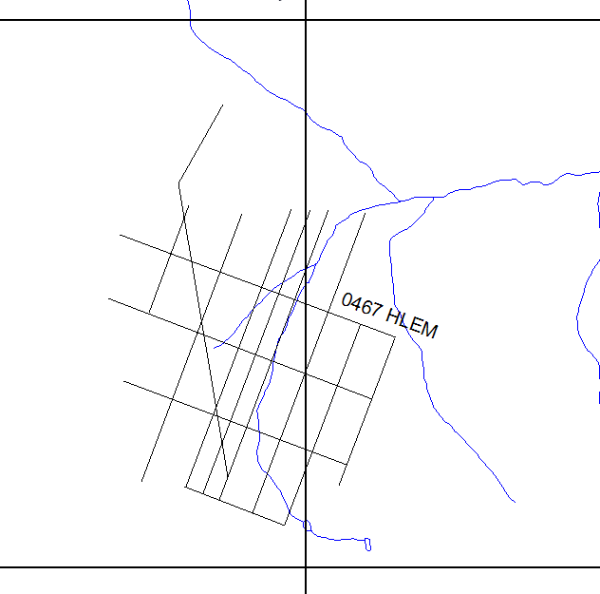
1. 00467: 1962, Conwest, HLEM

This work consisted of Horizontal Loop ElectroMagnetic surveying using an ABEM Gun with a coil spacing of 200 feet (60M) and station spacing of 100’ (30M). The report does not say which of the two available frequencies were used, 880Hz or 3520Hz. This is only two stations per coil spacing and insufficient. Standard minimum is three and more commonly it’s four. With only two stations per coil spacing, an anomaly can only be one reading. The data were carefully reviewed with this in mind. No anomalous responses are evident. Maximum depth of penetration would have been about 20M.

The Conwest report map was registered, from which the survey lines were traced and are shown adjacent.

2. 02995: 1970, McPhar, IP

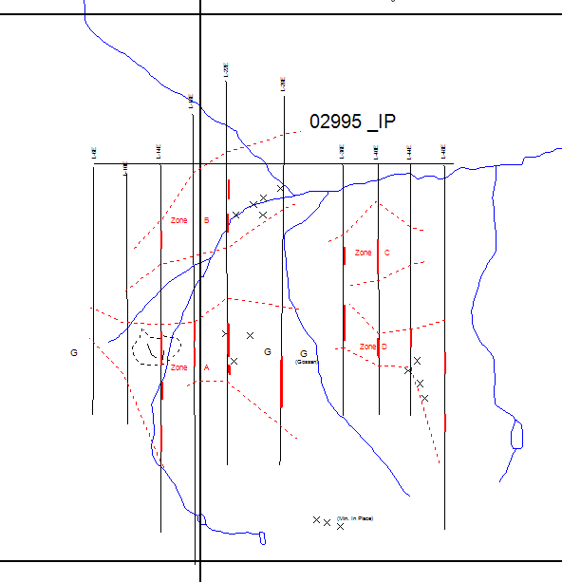
This work consisted of frequency domain (FD) IP, dipole dipole array, 3 separations, with dipole spacings of 200 feet, then detailing with dipole spacings of 100 feet. Ten N-S lines and a baseline were surveyed. FD IP is known to be very noisy and this is evident here. Nevertheless, four zones of anomalous chargeability were outlined with line to line continuity, zones A, B, C, and D. Within these, stronger zones are highlighted. Zone A includes the area of high grade boulders and trenching. X is mineralization in place and G is Gossan. High IP % frequency effects in the range of 15-20 are observed. This is roughly equivalent to time domain numbers of 75 to 100 mv/V using rule of thumb conversions, and so these values are very high. Post survey, a number of drill holes are reported to have targeted the IP responses without success. Depth of penetration of this IP is estimated at about 30M.
The report map was registered, from which the survey lines were traced and are shown adjacent, along with IP trends.

3. 07523: 1979, Cominco (Scott), VLF, IP
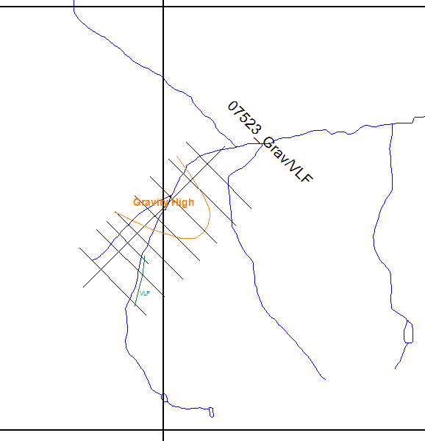

This work consisted of VLF and gravity on eight NW-SE oriented lines. A VLF conductor was interpreted in the SW part of the grid, correlating with the creek, which was later interpreted by ABM to be following a fault. It is thus most likely that the VLF conductor reflects the fault. A near 1 mgal Bouguer gravity high resulted in the central part of the grid as shown.

The report map was registered, from which the survey lines were traced and are shown adjacent, along with the location of the BG high and VLF conductor.

4. 08549: 1980, Cominco (Jackish), Mag, Gravity

This work consisted of mag and gravity to follow up the interesting gravity anomaly discovered in 1979, extending the previous grid. The report maps were registered, from which the survey lines were traced, then screen snagged for display herein,
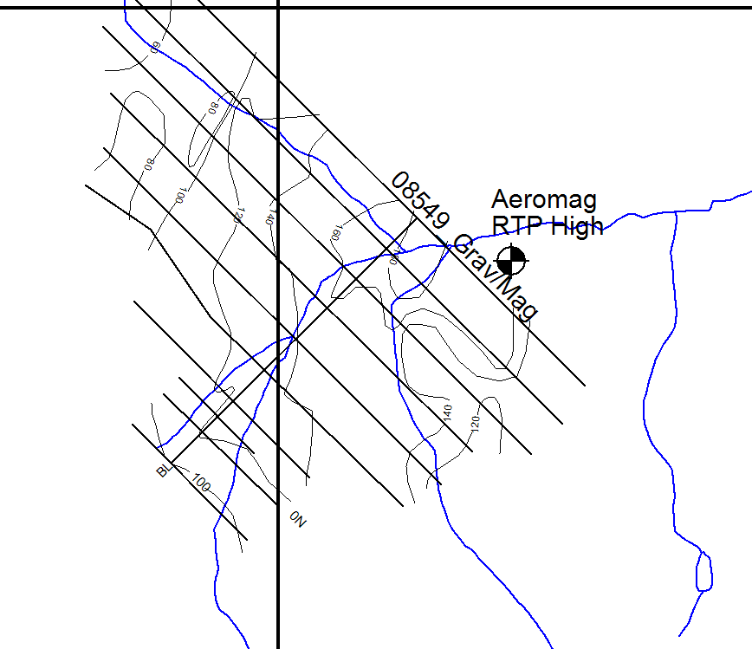

In the ground mag, magnetic values generally increase to the east of the grid, in concert with the aeromag whose RTP positive high is shown. Mag contours in adjacent image are 20nT. Comparison with aeromag RTP high is more appropriate because the TMI high moves progressively south with increasing aromag altitude, in this case about 250M.
(RTP=Reduced to Pole)

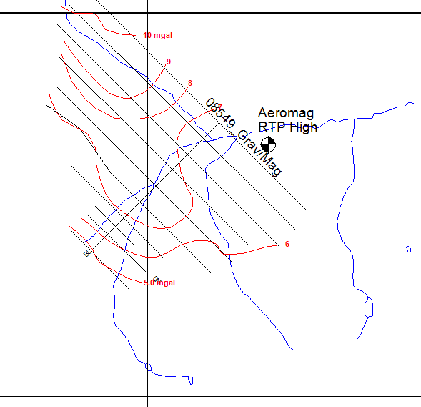

The gravity results shows a strong regional gradient increasing to the north, on which is superimposed an approx. 1 mgal bulge some 500M in size, consistent with results of the previous year, in the area of the creek, in the center of the grid. Gravity contours in adjacent image are 1 mgal.

These report maps were registered, from which the survey lines and major contours were traced and are shown adjacent.

I now recall what happened with this gravity anomaly within Cominco. The question arose as to whether the severe topography in the region could be a factor in this gravity anomaly. I remember being asked to compute the terrain effect in the area of the survey, i.e. the effect of the surrounding mountains and valleys, independently without knowing the actual gravity response. I used basic prism blocks, from which the gravity effect can be easily computed anywhere, to build the regional topography. After about 3 days of work, I achieved an answer which turned out to fit the observed response rather well. Recent communication with Al Scott confirmed that indeed this was the anomaly I had worked on. Furthermore, he told me that at the same time, he had his geophysical technician do a lengthy computation using the graticule graphical method, and he achieved practically the same result. The results of these computations are not available.

It’s not so much that there is a gravity high, but rather gravity lows on either side resulting in an apparent gravity high. The following illustrates this:

Consider a gravity line with a mountain at the left end and a valley at the right end, with normal gravity in the middle.

Mtn Grav Low Grav normal Grav Low Valley

From the normal gravity in the middle, going to the left towards the mountain will reduce observed gravity because the mountain is above the gravity instrument level, thus “pulls up”, reducing gravity. Going to the right will reduce observed gravity as well because the valley is an absence of mass under the gravity instrument level, thus reducing gravity. The end result is an apparent gravity high in the middle.

Although it is always possible that there is still a valid gravity response there, it’s near explanation by two independent computations of terrain effect downgraded it and then Cominco lost interest.

5. 0236: Geochem, 1970, Reeve.

This consisted soil sampling the B horizon and prospecting. Analyses were made for Ag, Pb, Zn, and Mn. The report maps were registered and are shown below with creeks and RTP aeromag positive high. The cross indicates the location of the proposed pipe derived from mag modeling to be discussed later:

Silver Lead
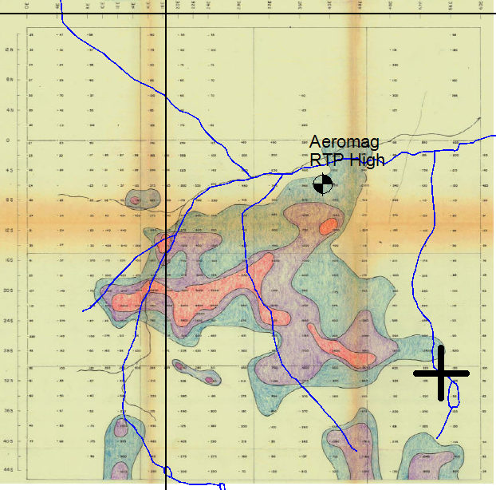
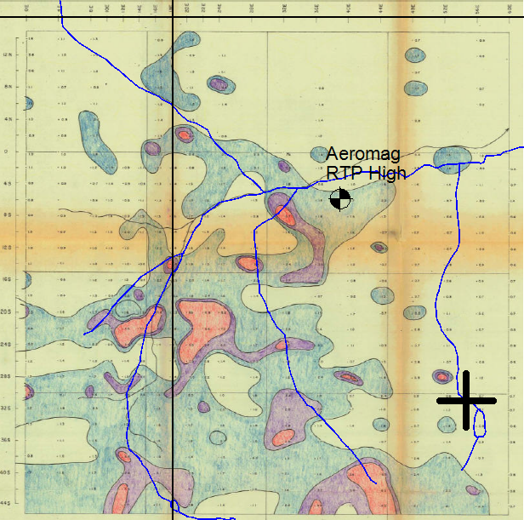

Zinc Manganese

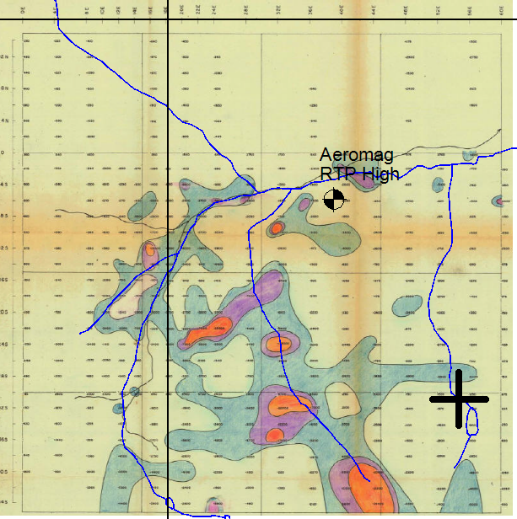
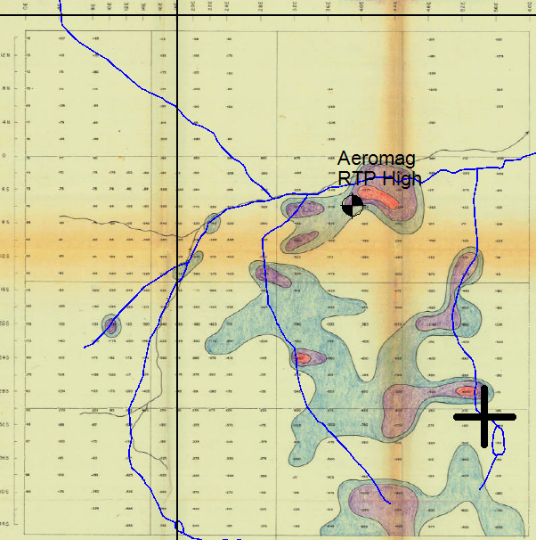

Mapping
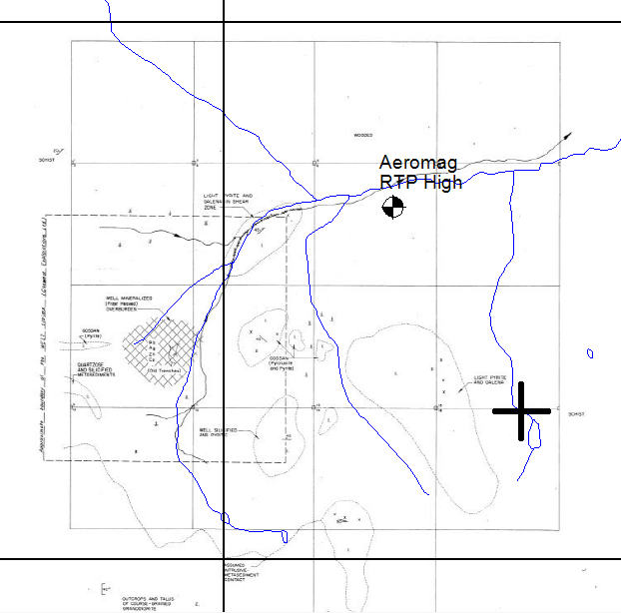

Crosshair is the location of the proposed pipe causing the magnetic dipole response.

There is a reasonable correlation of anomalous Pb soils and IP responses, but no real correlation with the apparent gravity high.

16898: Geology,VLF, Record of ABM comments, 1987, Skylark Resources

VLF results are not that robust. Value of this report is putting into the record comments by ABM on the property.

20517: Prospeting & Sampling, 1990, Formosa Resources

Nothing of new significance.

23774: Geochem, Geology, 1995, Ecstall Mining

Further geochem sampling to the SW of older surveys.

Aeromagnetics:

A high level fixed wing aeromagnetic survey was flown by the government in northern BC in 1995 and 1996 which included the area of the Frog property. Lines were flown E-W at a nominal line spacing of 800M. In the area of the Frog property, flight altitude above topography was in the 600M to 700M range.

As mentioned, the original digital line data were located and downloaded. The data were reduced to the pole, and are shown below with contours at 10nT, drainage, flight path in black, and 2km UTM grid in white. The location of the Frog trenches is shown. The strong anomaly in the SW corner is the Cassiar batholith. The NW-SE black line and crosshair will be referred to later.

RTP
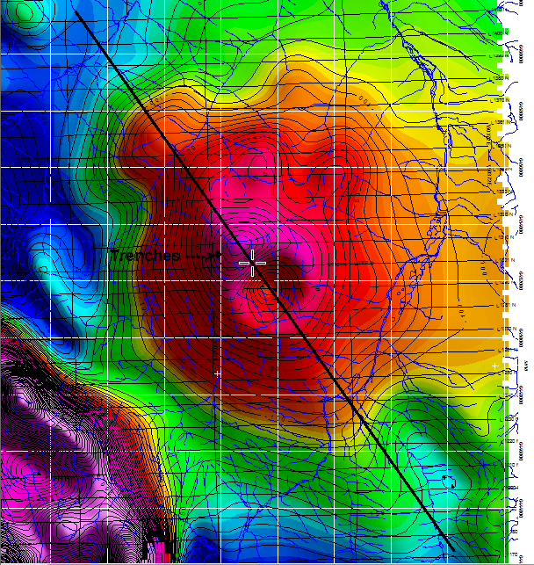

RTP Contours and creeks on a Google Image:
(note that text gets distorted and moved in creating such keystone markup files; trenches are correctly located at the black dot however)
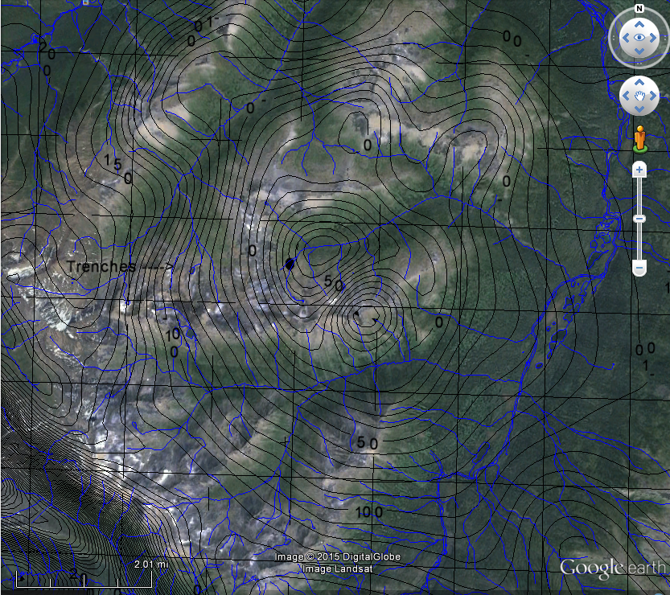

This next scan shows topography grid and contours at 20m:
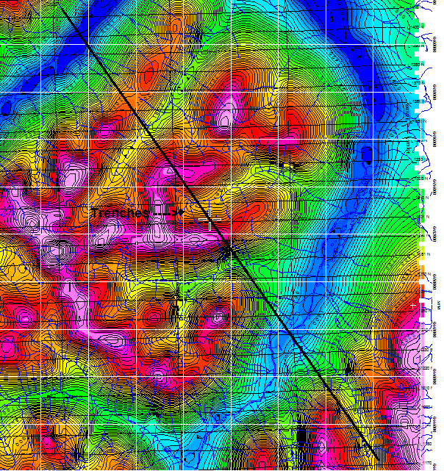

The immediate area of the Frog property is atop a large aeromag response. Upon inspection it appears to consist of two responses. First there is the large response from a deep source. Superimposed on that, in the center, there is a much shorter wavelength dipolar response, and the Frog workings are situated on the positive lobe of that dipolar response.

To investigate this, the elevation, mag sensor height, and RTP data were extracted at 200m interval on a 23 km NW-SE trending line, black line in above scans. This information was imported into a simple 2 ^{3/4} D mag modeling program. Following shows screen snags from that modeling (NWleft). Hor and vert scales are different. Lower diagram shows model cross section, topo points in orange dots, and sensor height in blue dots. Upper plot shows RTP data as red dots and solid profile is the model response.

A - Modeling of the regional large anomaly response:

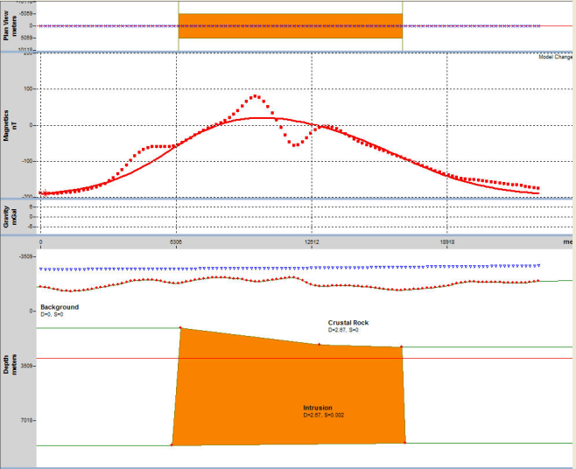

Fitting the regional response is easily achieved using a 10km by 10 km block (in plan) at a depth to top of about 3500M, and a susceptibility of 02.5 X 10⁻³ SI. This likely represents a deep intrusive body.

B – Modeling the Complete Response

Now it is possible to add a neck/pipe on top, about 200M X 200M in plan, then expanding up to about 400Mx400M in plan, that reaches within about 500M from surface, and whose top is remanently magnetized in a near horizontal direction to fit the smaller superimposed dipolar response shape.

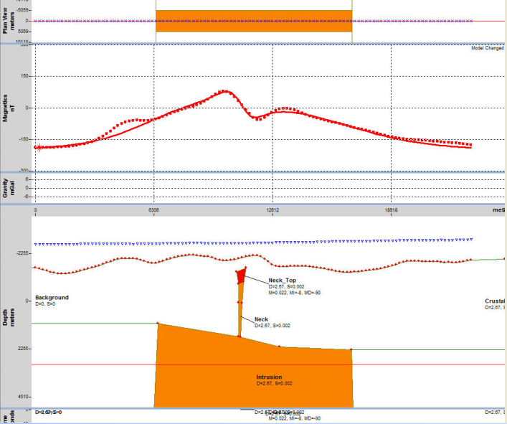

Although a fairly decent fit can be achieved, it is NOT a unique solution, only one possible solution. The top of the neck is located at the crosshair on the NW-SE line shown in above plans at 609125E, 6452580N, NAD83. The data could be equally fitted using a smaller target which is deeper and more strongly magnetized, or a larger target which is shallower and less magnetized. Another solution could be two closely spaced bodies, one normally magnetized producing the positive mag and another reversely magnetized producing the negative mag.

CONCLUSIONS

Assessment reports and government aeromag were reviewed on the Frog property of northernn BC. Important contributions are:

1. The apparent gravity anomaly had been downplayed by Cominco geophysical staff as being likely caused by topographic effects.

2. The government aeromag data suggest a deep magnetic source such as an intrusive, and a shallower remanently magnetized source in the vicinity of the Frog property. One possible solution to this situation is a narrow pipe like feature above a deep seated intrusion. The pipe could possibly reflect the magnetic calc potassic or potassic core of an alkalic porphyry copper system. In such a scenario, the Pb_Zn_Cu mineralization found to date on the property could be in the propylitic zone of the system. The mineralized fault in Hals creek hosting high grade could possibly be a part of a ring fault system whose center is to the ESE towards the proposed mag pipe. From this aeromag data, the proposed pipe location is about 1300m ESE of the trenches on the property, at 609125E, 6452580N.

3. No magnetic interpretation is unique. Another interpretation for the dipolar anomaly shape could be two adjacent intrusive pulses, emanating from a much deeper intrusive, one being normally magnetized and the other reversely magnetized due to emplacement when the earth’s field was reversed. Depth estimates would probably not change much.

RECOMMENDATIONS

The 800m line spacing and 600M height aeromag data has insufficient resolution for targeting of the proposed pipe structure. For best evaluation, the area should be covered by helimag and spectrometer. One possible contractor is Precisions Geosurveys based in Vancouver with a lot of experience doing small helimag surveys in northern BC. Another that would include deep penetrating EM is Geotech with the VTEM system, but obviously at higher cost. Failing that, lower quality ground mag could be done. Prospecting, mapping, and geochem could be done in the area surrounding the proposed pipe for supporting indicators. If results are positive, much higher sensitivity and depth penetrating IP could be done for targeting sulphides.

Short note by

“Jules J. Lajoie”
--------------------------------
Jules J. Lajoie, PhD, PEng
Comtek Enterprises Ltd.
Vancouver, BC

